Python OOPs Concepts

Like other general-purpose programming languages, Python is also an object-oriented language since its beginning. It allows us to develop applications using an **Object-Oriented approach.** In [Python](https://www.javatpoint.com/python-tutorial)

, we can easily create and use classes and objects.

An object-oriented paradigm is to design the program using **classes and objects.** The **object is related to real-word entities** such as book, house, pencil, etc. The oops concept focuses on writing the **reusable code**. It is a widespread technique to solve the problem by creating objects.

Major principles of object-oriented programming system are given below.

* Class
* Object
* Method
* Inheritance
* Polymorphism
* Data Abstraction
* Encapsulation

Class

The **class c**an be defined as **a collection of objects**. It is **a logical entity** that has some specific **attributes and methods**. For example: if you have an **employee class**, then it should contain an **attribute and method**, i.e. an email id, name, age, salary, etc.

Pause

Unmute

Current TimeÂ 2:24

/

DurationÂ 4:57

Loaded: 100.00%

Â

Fullscreen

x[[](https://campaign.adpushup.com/get-started/?utm_source=banner&utm_campaign=growth_hack)](https://campaign.adpushup.com/get-started/?utm_source=banner&utm_campaign=growth_hack" \t "_blank)

**Syntax**

1. **class** ClassName:
2. <statement-1>
3. .
4. .
5. <statement-N>

Object

The object is an entity that has

**state and behavior**. It may be any real-world object like the **mouse, keyboard, chair, table, pen, etc.**

Everything in Python is an **object**, and almost everything has **attributes and methods**.

Functions are methods

All functions have a built-in attribute **\_\_doc\_\_,** which returns the docstring defined in the function source code.

When **we define a class**, **it needs to create an object** to allocate the memory. Consider the following example.

**Example:**

1. **class** car:
2. **def** \_\_init\_\_(self,modelname, year):
3. self.modelname = modelname
4. self.year = year
5. **def** display(self):
6. **print**(self.modelname,self.year)
8. c1 = car("Toyota", 2016)
9. c1.display()

**Output:**

Toyota 2016

In the above example, we have created the **class named car**, and it has two attributes **modelname and year**. We have created a **c1 object** to access the class attribute. The c1 object will allocate memory for these values. We will learn more about class and object in the next tutorial.

Method

**The method is a function** that is **associated with an object**. In Python, a **method is not unique to class instances.** Any **object type can have methods**.

Inheritance

Inheritance is the most important aspect of object-oriented programming, which simulates the real-world concept of inheritance. It specifies that the child object acquires all the properties and behaviors of the parent object.

By using inheritance, we can **create a class** which uses all the **properties and behavior of another clas**s. The new class is known as **a derived class or child class**, and the one whose properties are acquired is known as **a base class or parent class.**

It provides the re-usability of the code.

Polymorphism

Polymorphism contains two **words "poly" and "morphs**". Poly means **man**y, and morph means **shape.** By polymorphism, we understand that **one task** can be performed in **different ways**. For example - you have a **class animal**, and **all animals speak**. But they **speak differently**. Here, the **"speak" behavior is polymorphic** in a sense and depends on the animal. So, the abstract "animal" concept does not actually "speak", but specific animals (like dogs and cats) have a concrete implementation of the action "speak".

Encapsulation

Encapsulation is also an essential aspect of object-oriented programming. It is used to **restrict access to methods and variables**. In encapsulation, **code and data are wrapped togethe**r within a single unit from **being modified by accident**.

Data Abstraction

Data abstraction and encapsulation both are often used as synonyms. Both are nearly synonyms because **data abstraction is achieved through encapsulation**.

Abstraction is used to **hide internal details** **and show only functionalities**. Abstracting something means **to give names to things** so that the name captures the core of what a function or a whole program does.

Object-oriented vs. Procedure-oriented Programming languages

The difference between object-oriented and procedure-oriented programming is given below:

Object : everything is object

Has attributes : height, age

It has behaviour like walking taking – functions- methods

We can store data ( we need to define variables)

What ever we do can do help of object

Class:

Designed of object so we get object

Once we design class – produce many objects

Blue print

If we want object we need to create class

Define class

Class computer:

Def config(self):

Print(“i5,16gb,1TB)

Com1=computer()--- its object of computer

Now object: comp1

Class should have

1. attributes(variables)

2. behavious- methods( functions) – starts with def

X=9

Print(x)

Class int

X is a object

Obect is called with class name

Com1=computer()

Everything object in python

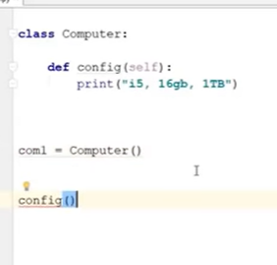

Above give error

Inorder to use method name

Use:

Class.method()

Computer.config()

But every oject is diff.. if I say someone to walk. I need to tell who should walk

Computer.config(com1)

So here we are passing object as paramer.

It will take self in method.

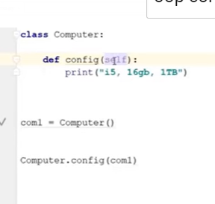

Now com2 is another object

Computer.config(com1)

Or class.method(object)

Or

com2.config()

above this also will work

com1 will be placed in place of self

--

Def config(self)

Self is object we are passing as parameter

Com1.config()

Config method will take com1 as parameter

--

Object has attributes and methods(behavious)

--

We can call method from object:

Object.method()

--

2 variables:

Type of cpu

Ram

--

Special method available in class :

--name—(for variables)

Methods: \_\_init\_\_

Def –init—(self):

Self : compulsory

--

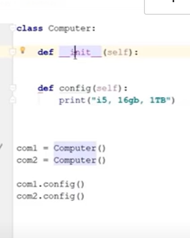

Idea behind init is:

It will be called automatically

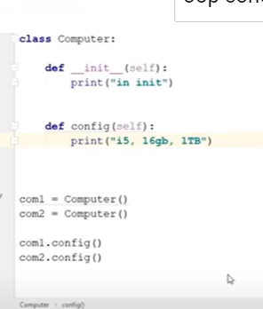

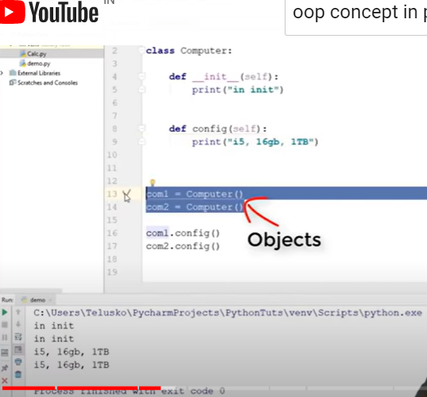

Init exceucted

2 times because com1

Com2 called 2 times

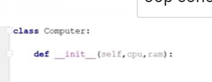

We are passing 3 parameters

Self is object,

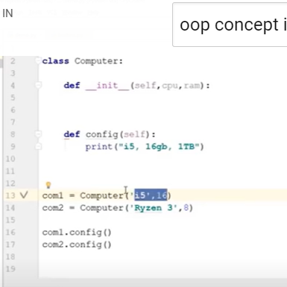

So while calling

Com1.computer(“i5”, 16)

The above we have mentioned only 2 parameters

3rd one self= object name

--

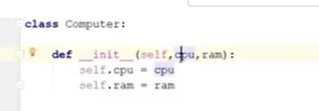

Every object must have value

Here cpu and ram are just arguments

If we want it should be a part of object

Then

Seld.cpu=cpu

Self.ram=ram

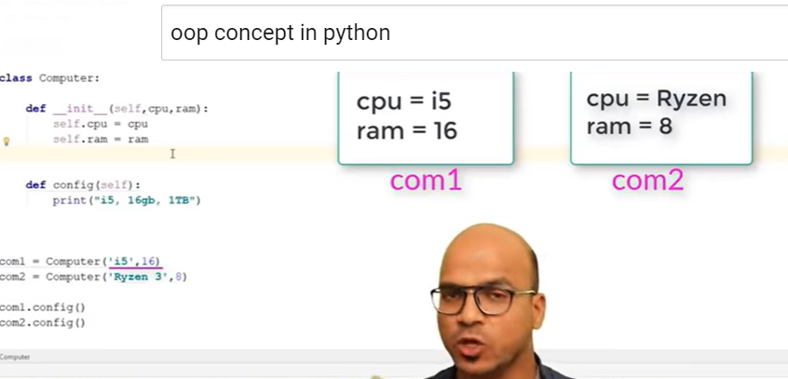

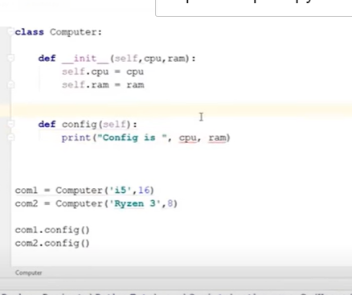

We get an error

Cpu belongs to object not local

So we need to add self.cpu

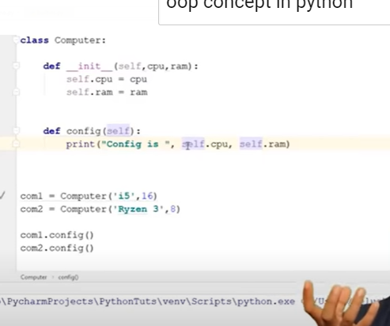

1. constructor
2. self

constructor:

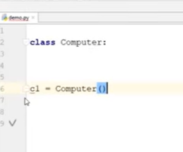

C1 is oject

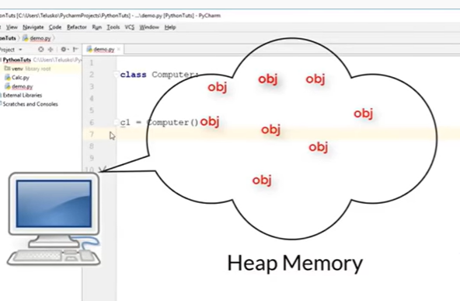

Every obj will have some memory

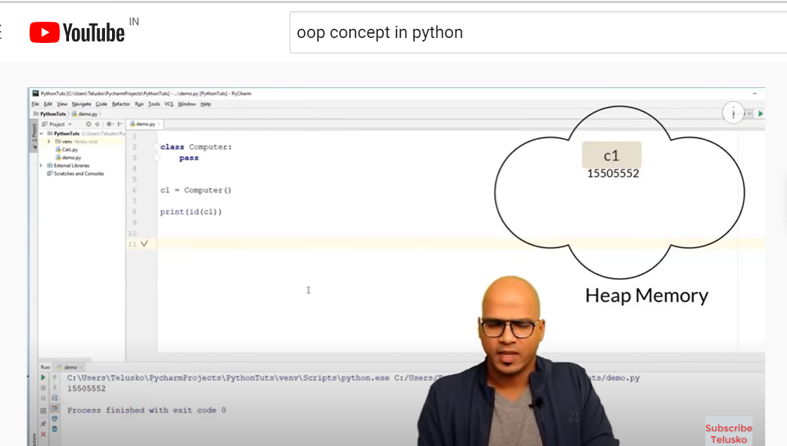

We get address of diff objects

Every time we create obj will have memory

How much space it requires

Size of obj: decided by number of variables

Who is responsible for allocating required memory is constructor.

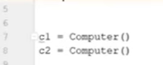

() is a constructor

(it calls init internally)

How to define variables??

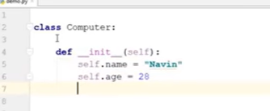

2 variables name and age

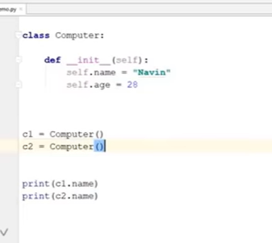

We get same name for each object

We can change names

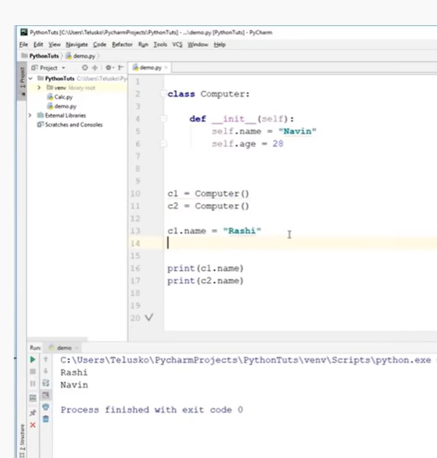

If I want to change parameter of one object

2 ways

C1.name=”rashi”

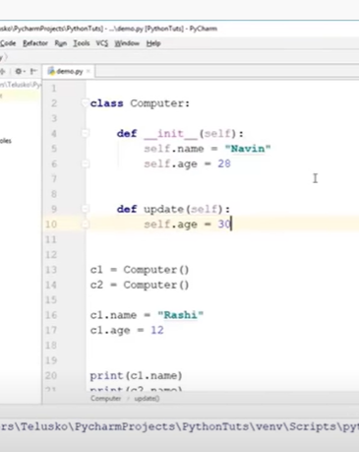

Now in another function we are changing age with update method

Now to call update

How to call?

With object name or class name?

Self is pointing in update to which object’

While calling

C1.update()

C1 will be placed in self

--

When I want to compare 2 objects

If c1==c1:

Print(“they are same”)

Python don’t know how to compare

In this we will use separate function:

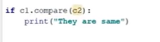

Again compare is not inbuilt function

We need to write method



Here self is c1 as we are calling update with c1 object

Other is c2 as we are passing as parameter

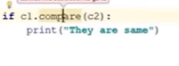

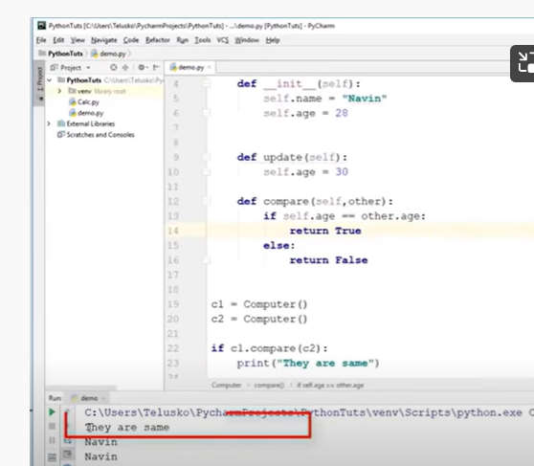

**Variables:**

2 types

Instance variables

Class variable(static)

Every object should know somethis= variable

Class car

Car has diff variables

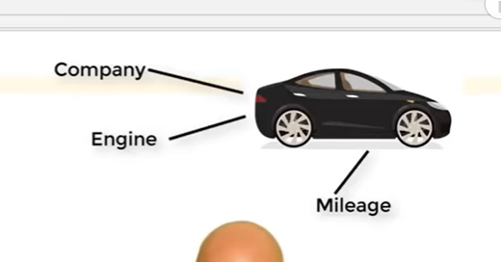

How to use variables inside class

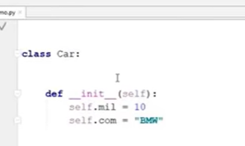

For every object variables changes

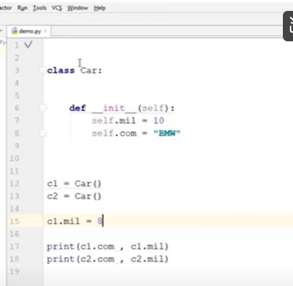

Number of wheels same

If u defines variable(common for all objects)-we define variables outside init – class variables

If we define variables inside init is : object variables - instance variable

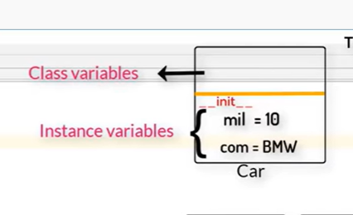

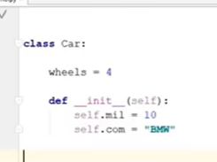

How to print

We can call class variables also with object name as object belongs to class

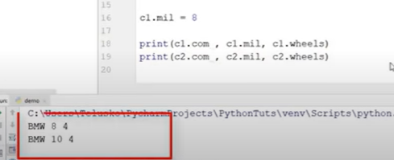

Instead of object we can also use class name



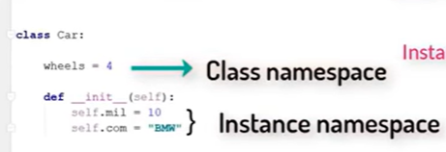

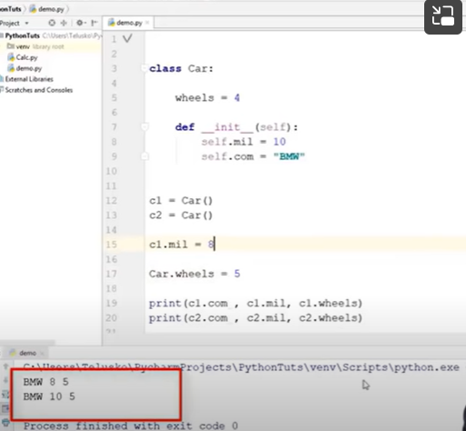

When I want to change wheels

We need to write

Car.wheels= 5

It belongs to class ( for all objects)

Which effects all objects when we change

--

Diff types of methods:

Operations

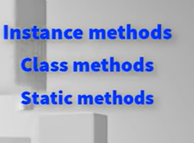

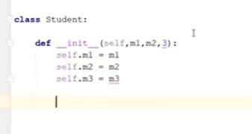

We have 3 variables for marks

When user has to pass marks can be used like above

Now create objects

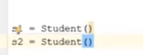

Now pass marks

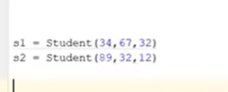

Now create static variable:



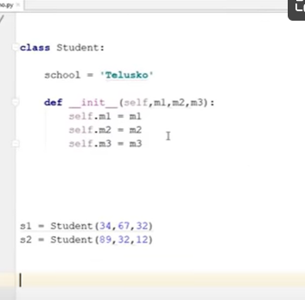

Now I need to perform avg

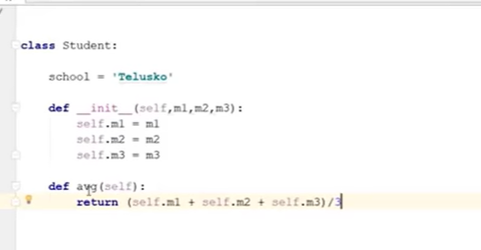

This in instance method

Since we are using self

For calling

We need to use object.avg

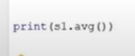

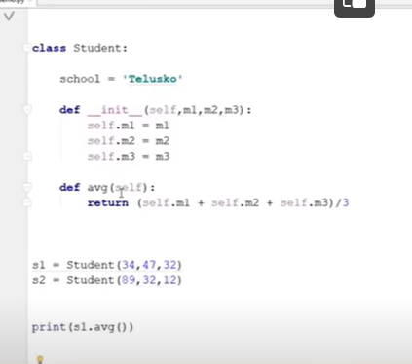

Instance method are two types



Just to fetch instance variables: accessor methods

To modify instance variables: mutator methods

Ex: fetch values of m1

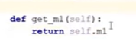

Change

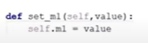

3 variables= 3 get methods

To work with class variable school: we need to use class method

Here not self

We should use – cls

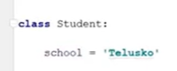

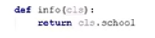



Above calling mthod didn’t work

Why?

When we create class method, we should use decorators

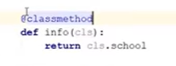

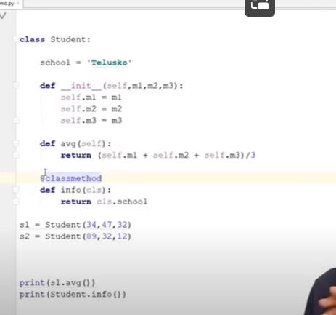

Static method:

Nothing to do with class or instance variables

Something diff not concerned with variables of class or instance

When I want info about “class method “ or any method used

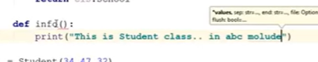

We need to use special decorato

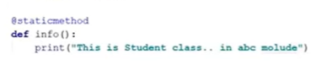



When u are using some method which has nothing to do with either class or object variable

We can use static

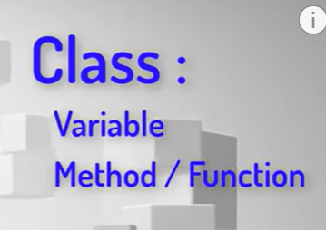

Can we have class inside a class

Inner class:

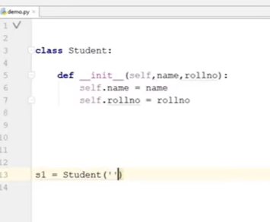

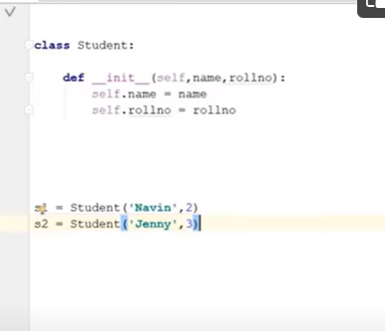

When I want to print all details about s1 object

We need tp print like below

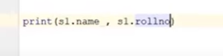

Below doent good for all objects

We need to write every object

So we need to write some method it should print all inf of s1 object,

Ex lets consider that method as “show”

we call s1.show() -- it should give complete inf of s1

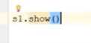

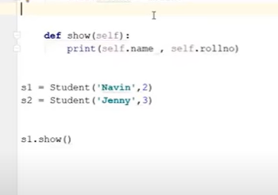



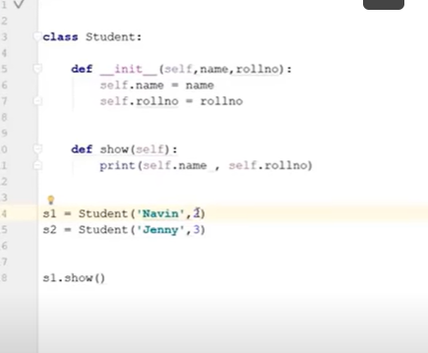

For example if u want to know laptop of ur students

Laptop is just not name , we want to know all details –

We can also do like below

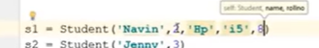

We can also can have another class laptop inside student

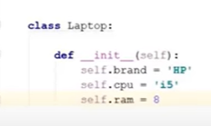

Where to create object for laptop?

We need to create object inside init of main student class class

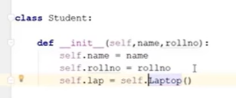

Calling inside of inner and outer class



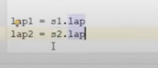

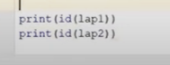

2locations = created

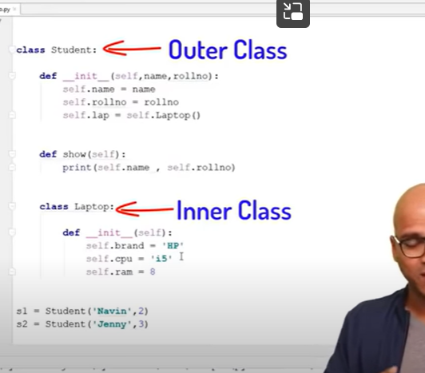

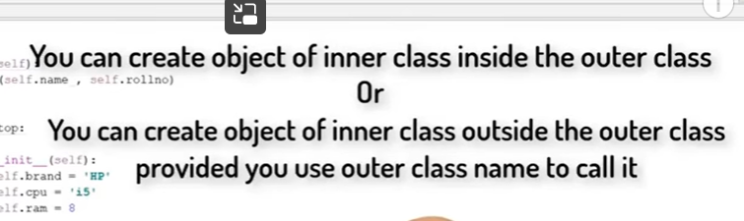

Outside of outer class

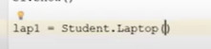

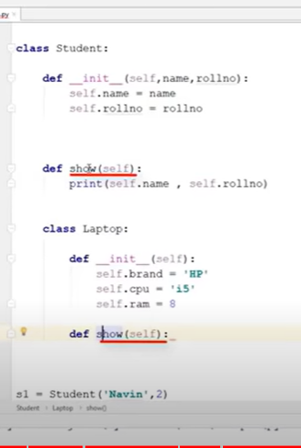

We can create show method inside laptop class

Here we have 2 diff show methods

One is for student class

2nd is for laptop class

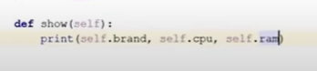

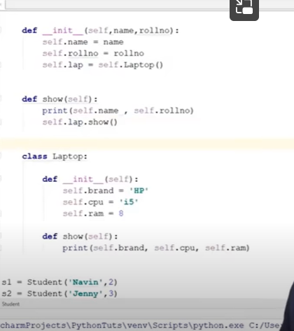

INHERITANCE:

Whatever our parents belongs to us

Class inherit a class

If we have class a and class b

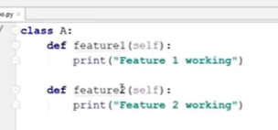

Class a has 2 features

Now create object for class

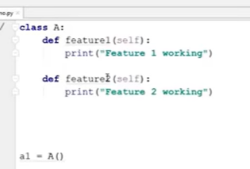

Now call features by using objects

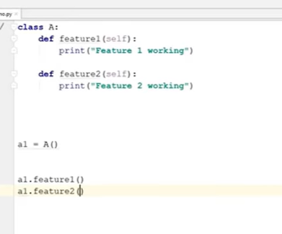

Now create other class B

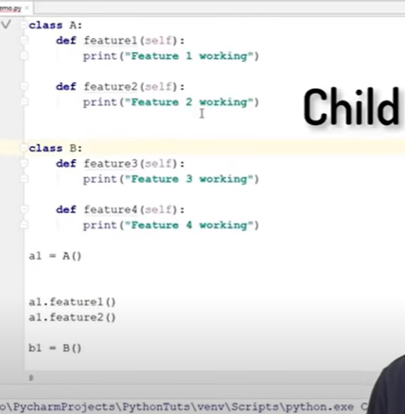

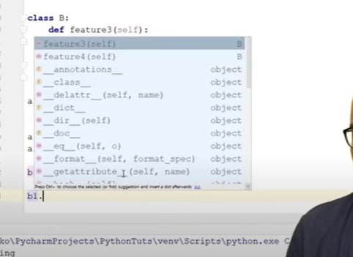

B1 object can access only feature3 and 4

If b is sub class of A

B can inherit all features of A

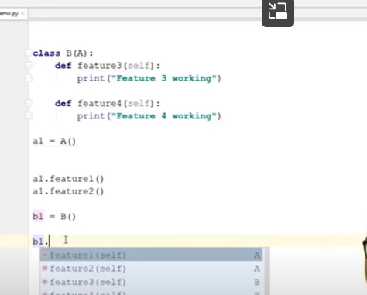

B can get access to all features of A

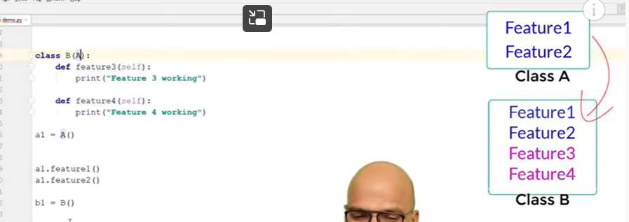

Now b1 object can have access to

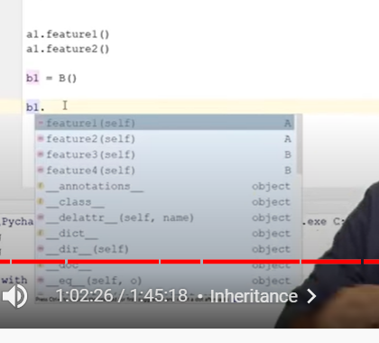

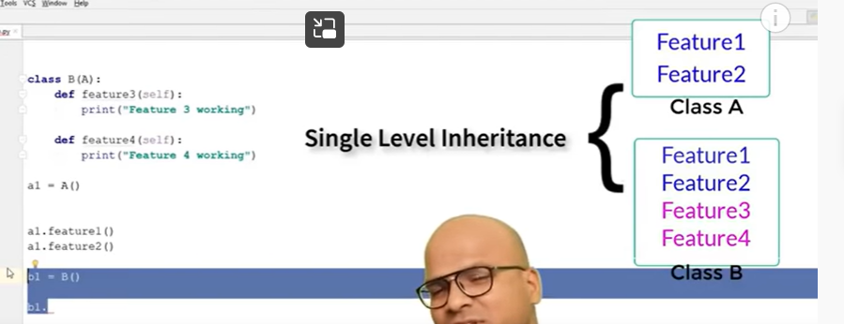

We can have multi level inheritance :

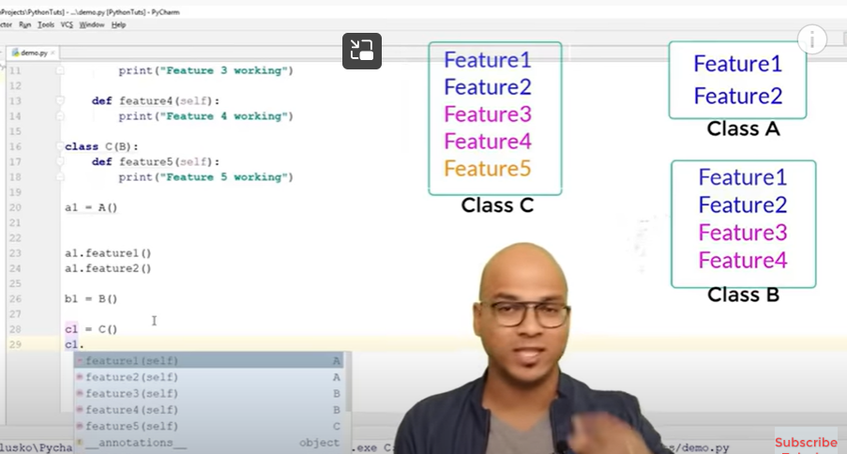

Child has access to features of parent and grand parent

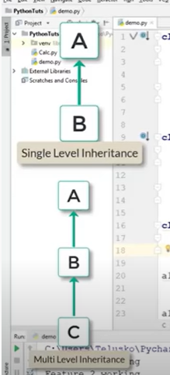

--

If there is no relation between A and B

C can access from both a and b

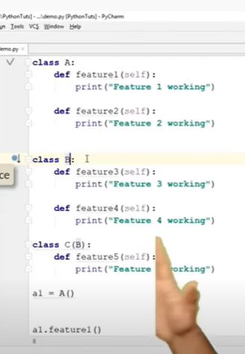

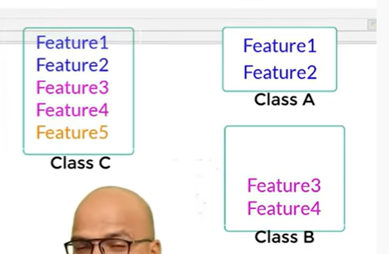

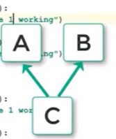

Above is multiple

--

Constructor in inheritance:

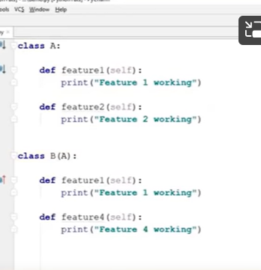

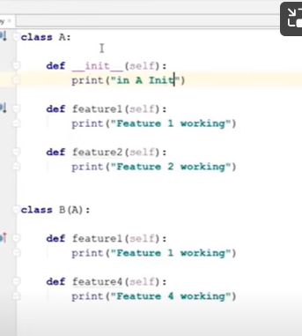

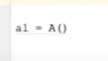

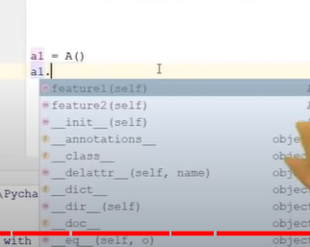

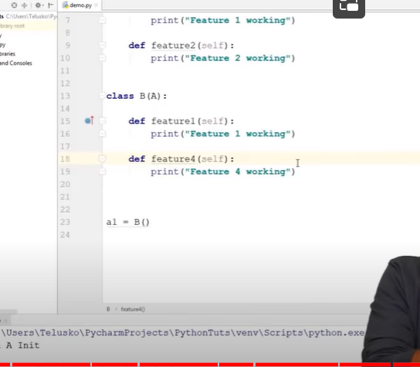

A1 calls B init

When I create object of B

Which calls constructor of A

Since b has no own constructor

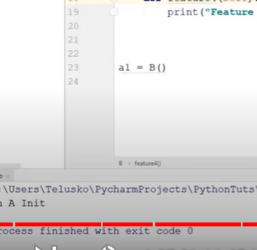

What if we have our own init

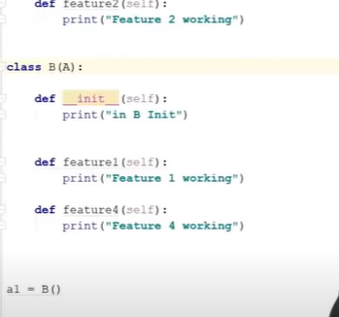

Which init it will call

When we create object of b

It first call init of B

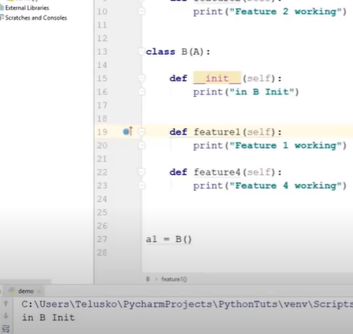

If we want to call both A and B

Super can call parent init

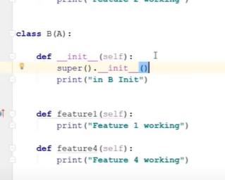

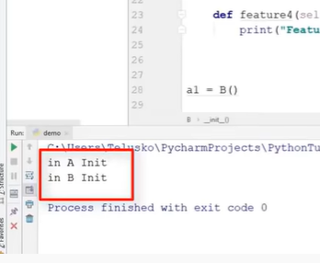

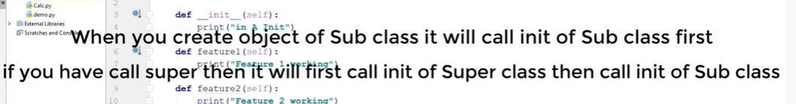

Now A and B not related to each other

C inherit from both A and b

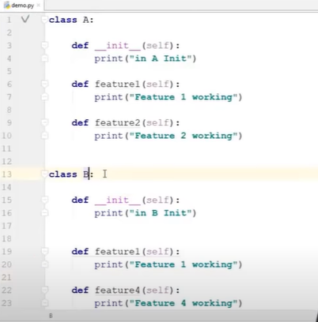

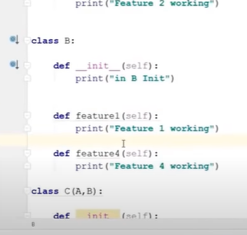

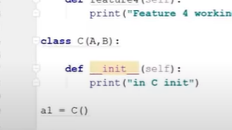

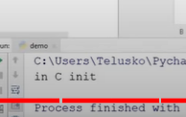

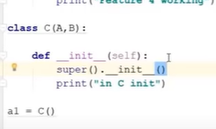

Now using super

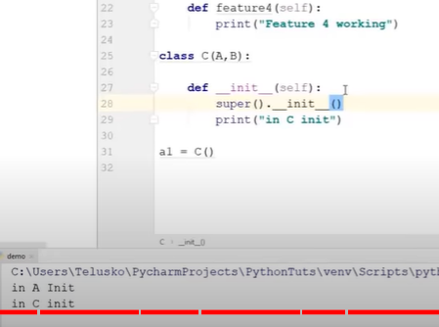

Now calling , its only calling A, C not B

Biased

--

Concept of MRO(Method resolution Order)

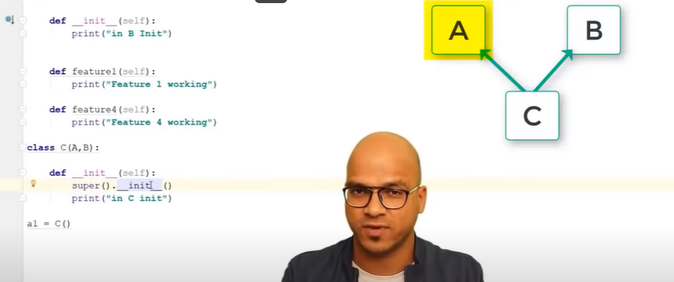

It prefer left

Its even same for method

If A and C class has same method with same name, feature1

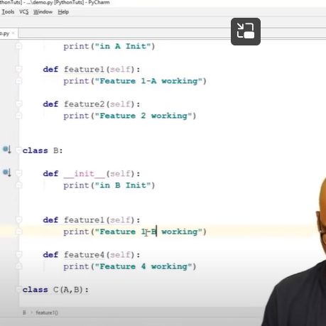

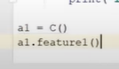

It calls A only

--

Method resolution Order:

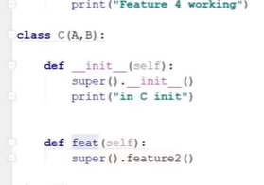

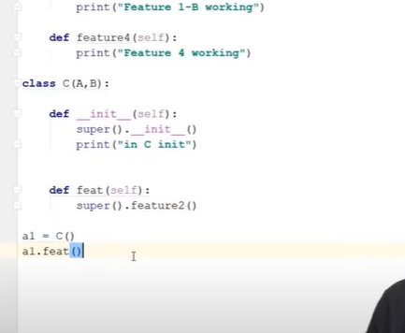

We can use super clase to call other methods

--

Polymorphism:

Poly : many

Morp: forms

--

Onething can take multiple forms

We bahve differently at diff locations

Object has multiple forms

4 ways to implement :

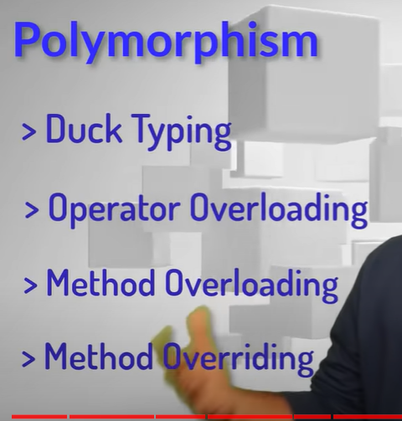

Duck typing:

We have class laptop

I need to write a code- its method

For that we need IDE

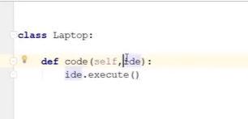

Ide is something diff

That’s why we did execute

It means ide does execution

So we need to have ide as class

That does method- execute

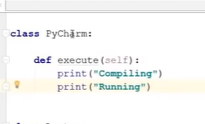

Now call code

Create object

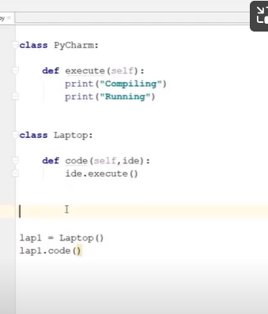

But inside code we need to pass ide

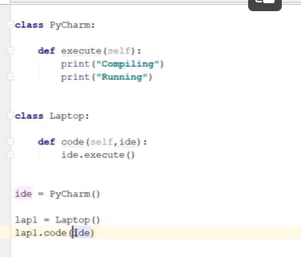

Type of ide here is pycham

Can we change ide?

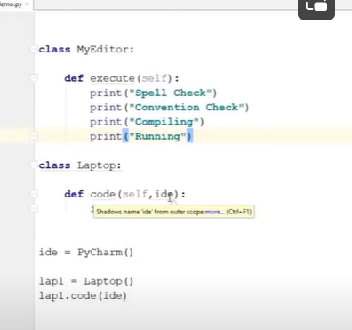

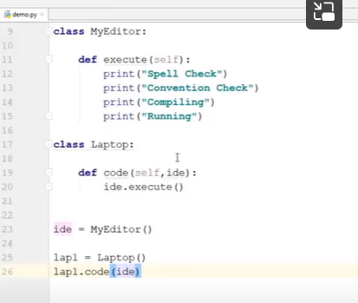

Ide is not fixed

So any class :- that object should have execute method

If object has method called execute – duck typing

--

This is how interface will work

--

**Operator overloading:**

**Add 2 operands(2,3)**

**Add 2 strings**

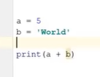

**We cant use**

**Int is class here**

**Every class has methods**

**..**

**For example**

**If we type**

**Int.**

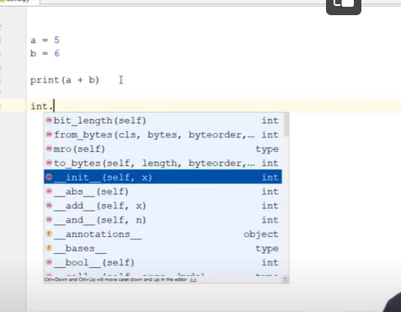

**We get all methods**

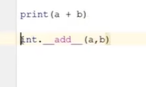

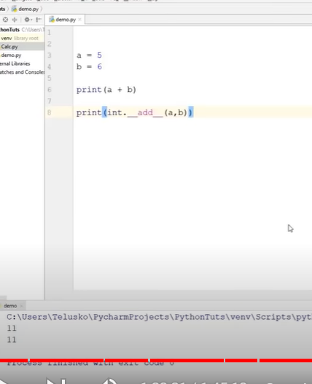

**Both will work in same way**

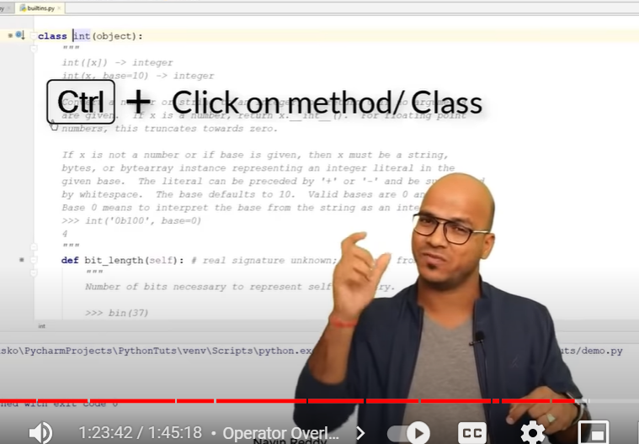

**Even if we use**

**Print(a+b)**

**Below method getting called at back screens**

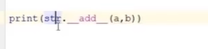

**It call diff methods behind screens**

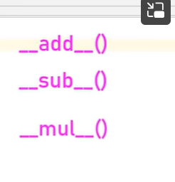

**For every operators(+,\_,\*)**

**Ex**

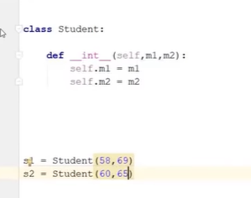

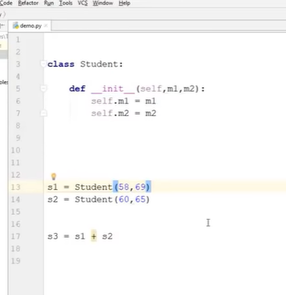

**Un supported**

**How can we combine students**

**In our class we don’t have add method:**

**Create method(overload method, change the nature ofmethod)**

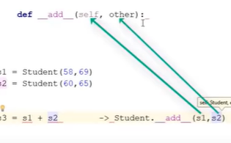

**Behind seen this code converted to**

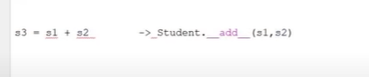

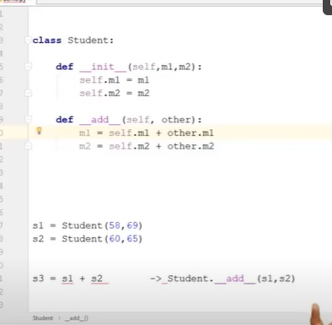

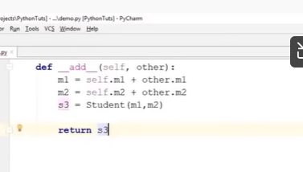

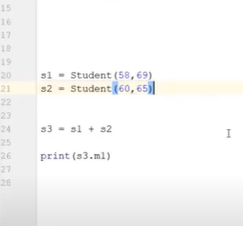

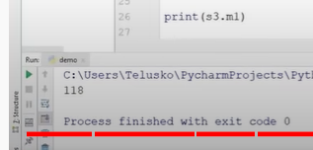

**--**

**We are overloading operators**

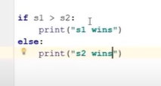

Above will not work

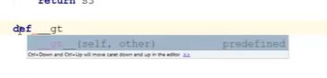

Gt is greater than

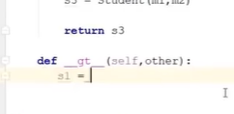

Self = s1

Other = s2

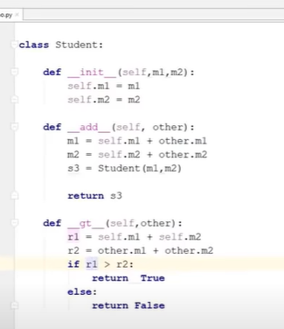

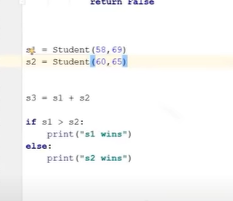

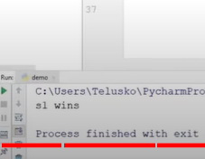

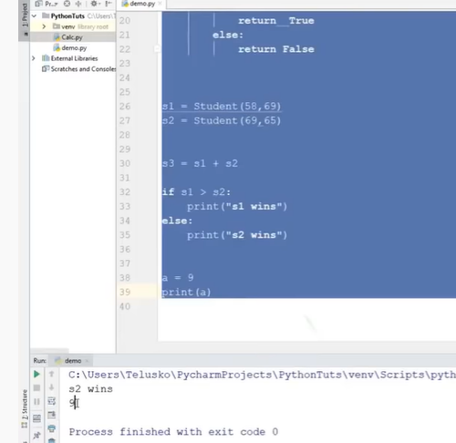

It prints a value

If we want s1

Its prints : location

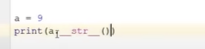

Behind the screen its calling str

But when we are calling s1

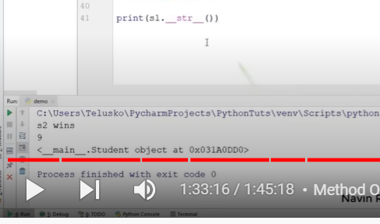

Its still calling s1 location

Because

Str prints only location

So we need to override that method:



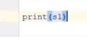

Still gets error

We need to return string values

So we need to format



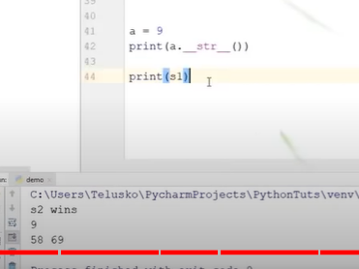

Now worked

This is how Operator overloading works

Operators will not change but operends will change

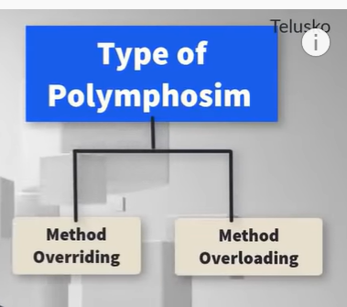

**Method overloading : python don’t support**

**If we have class**

**In that class 2 methods with same name with diff parameters**

**One method takes 2 parameters**

**2 takes 3 parameters**

***Method overriding*:**

**Same class**

**Same method name same parameters called overriding**

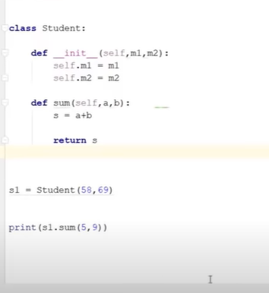

**When we are passing 2 arguments in sum method**

**Accepting two parameters while calling**

**It works’**

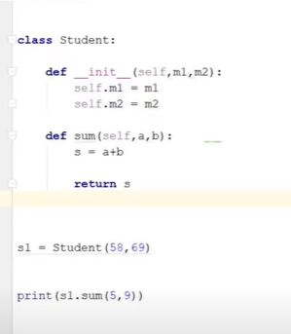

**Even passing 3 parameters and accepting 3 parameters will work**

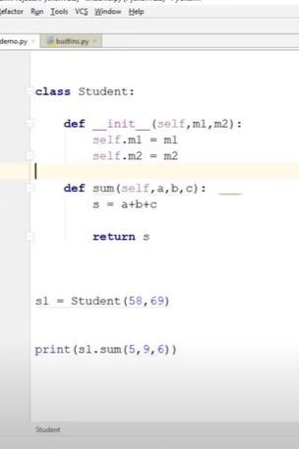

**What if we pass 3 parameters in method and accepting only 2**

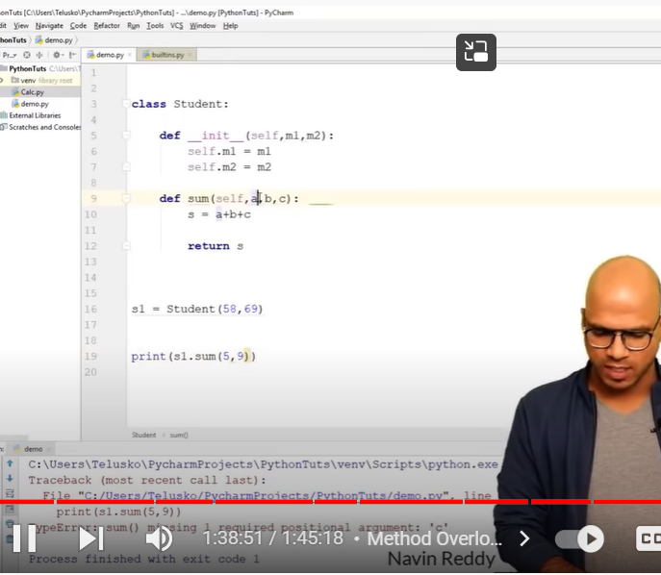

**How to solve this**

**None**

**Even if don’t pass values, default takes non**

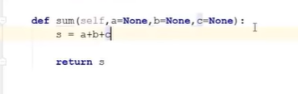

**What if we pass 2**

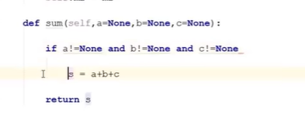

**It means we are passing all 3 arguments**

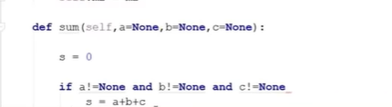

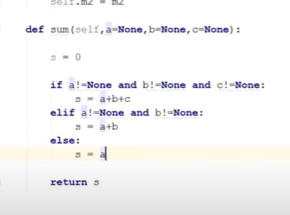

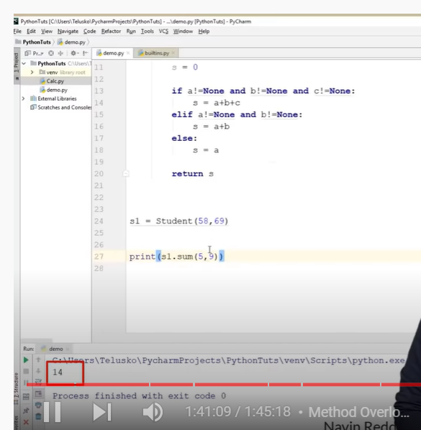

**Above is called method overloading**

**--**

**--**

**Now method overriding:**

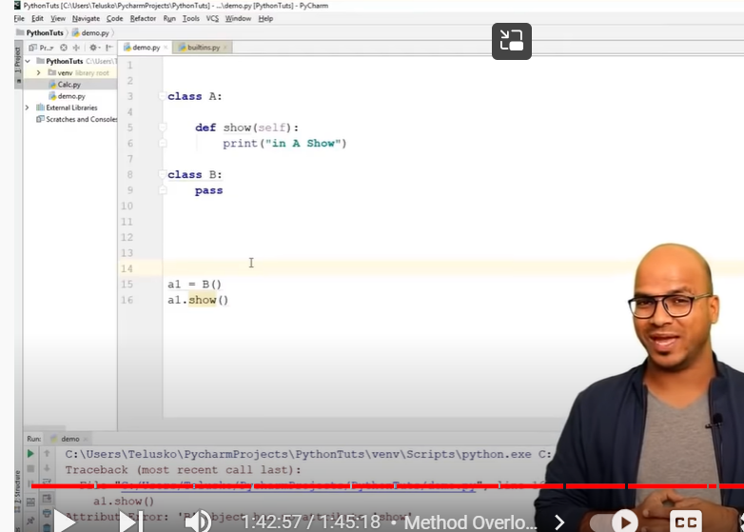

**Gets error since b has no attribute to show**

**Now use inheritance**

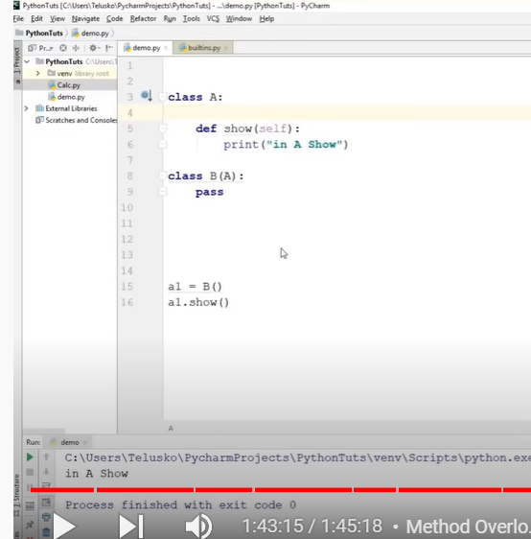

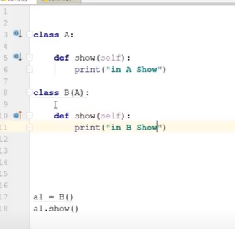

**Now b also has show method**

**The movement we create show method in child class**

**It will print child show**

**It overrides**

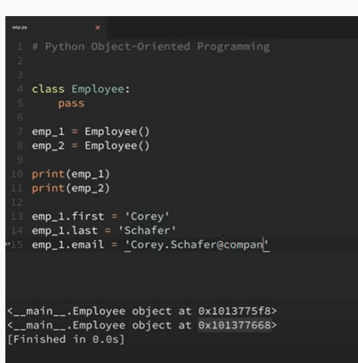

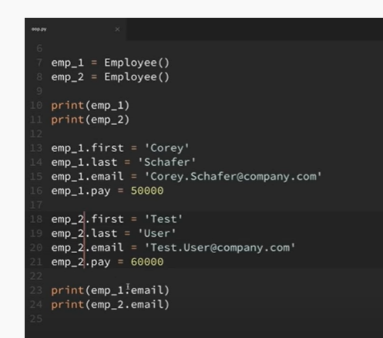

Instead of creating variables every time

Inside employee class

We use init ( constructors)

Create constructor \_init\_\_

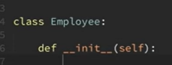

When we create method inside a class

It will receive instance(self) automatically

After seld we need to mention arguments

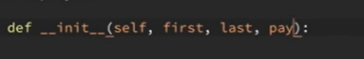

Now we need to set all instance variables

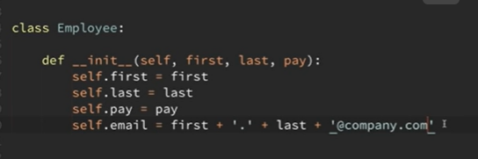

Now create objects

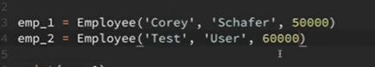

Self is automatic

emp\_1 will be automatically consider as self

when I want to get full name

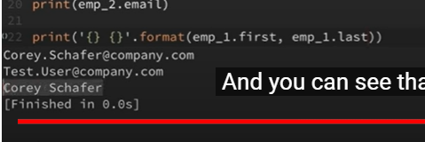

For for every empl its diff

So we need to create method inside class

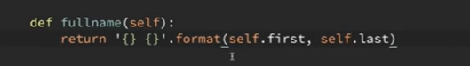

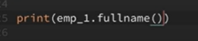

Since it is method

We should use fullname()

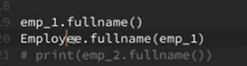

We can call method by using both class and instance

When we are calling method through class we should pass instance as argument of parameter

When we calling method through instance, doesnot require , as instance takes – self place

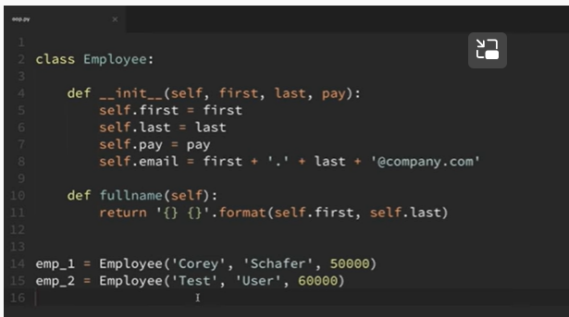

Instance variables are diff for diff instance]

Or instance variables are unique for instance

--

Class variables: shared to all instance

Its same for all instances

--

Better use care

Create a method

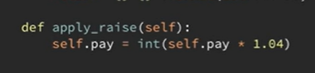

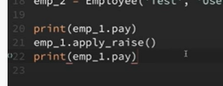

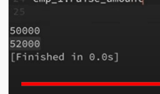

Raised

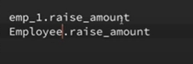

Raise\_ amount is not existed

Instead of using 1.04 for everytime

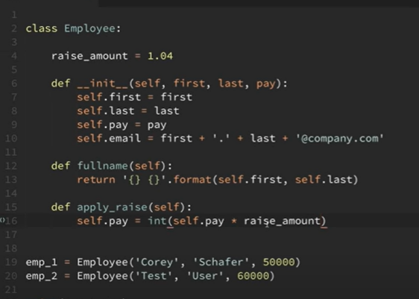

Got error

Since that raise amount(class variable) can be accessed either through instance or object

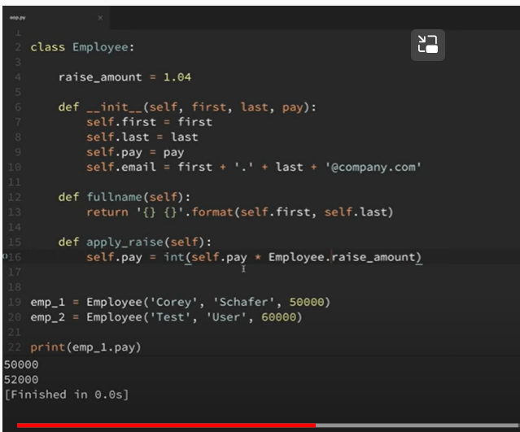

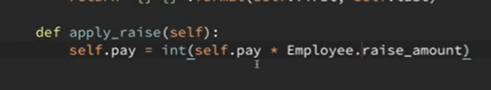

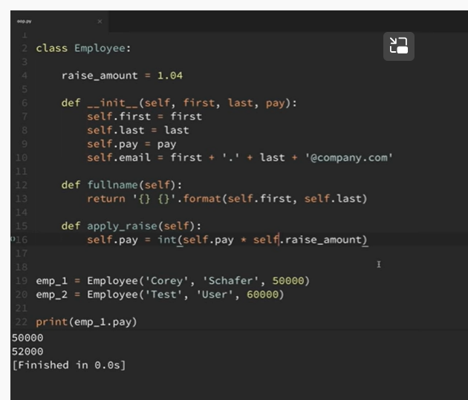

If these are class variables how can we access through instance:

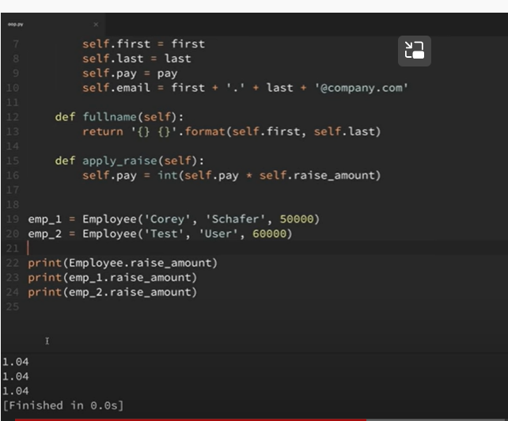

When we try to access attribute through instance

It will first check if instance has that attribute

If not it will check if class has that attribute

If they don’t have :

They are accessing class attribute

If call like below

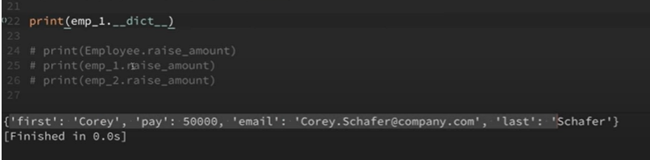

We can see no raise amount

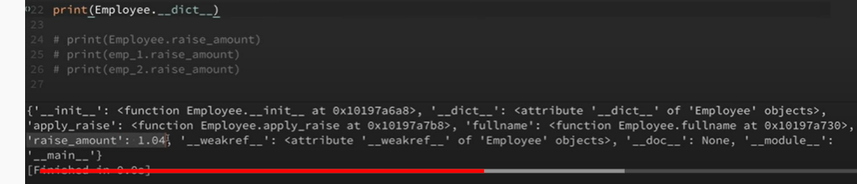

We can see raise amount in class

Now if I change raise amount

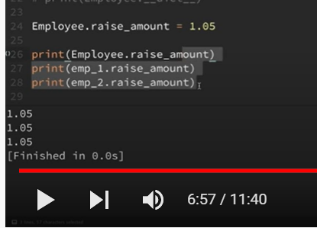

It changed for all of instances too

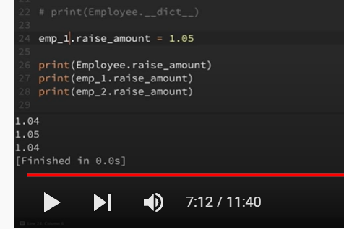

It got only changed to emp1

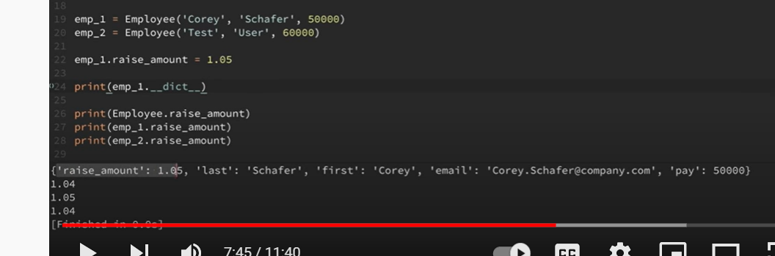

Now it creates variable under stance

-

Now another variable

Num of empl

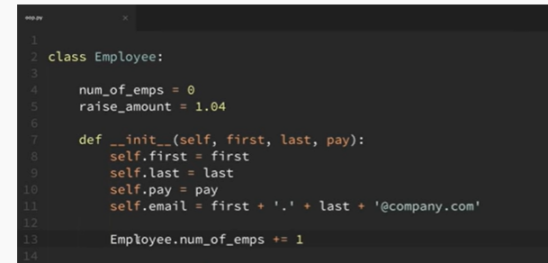

Whenever I add instance init methpod gets initialized

So I will increment um\_emp

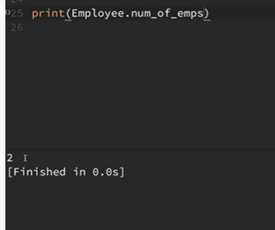

Because it incremented twice

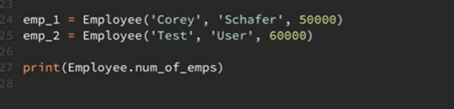

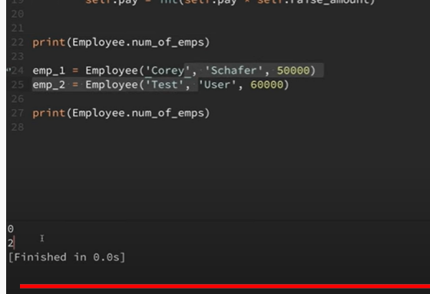

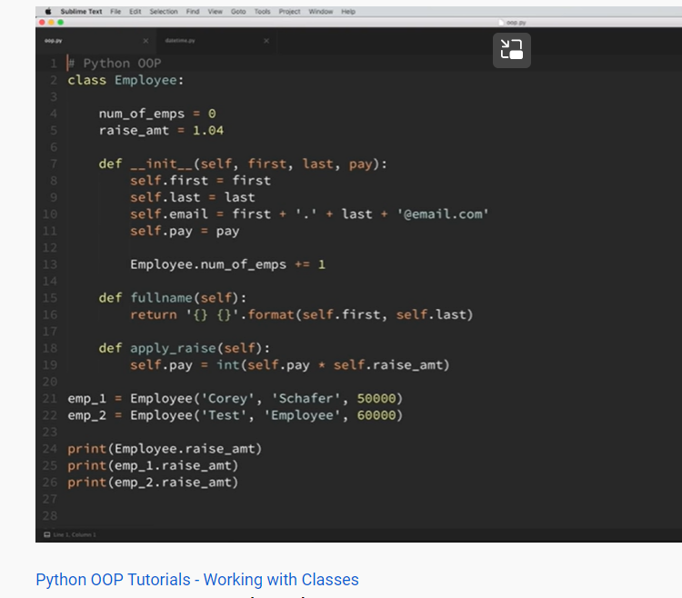

Regular methods

Class methods

Static methods

Regular method;

Takes instance as first argument

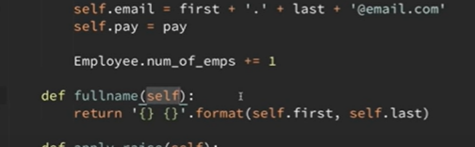

How to change where it wont take automatically instance as argument

We need to create class method:

It should take class as a first agument

We must use class method decorator



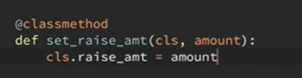

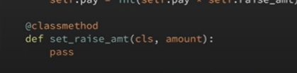

We cant use class instead of cls

Class is used to create class name

Cls variable

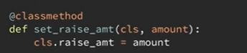



We should call that method by using calss name

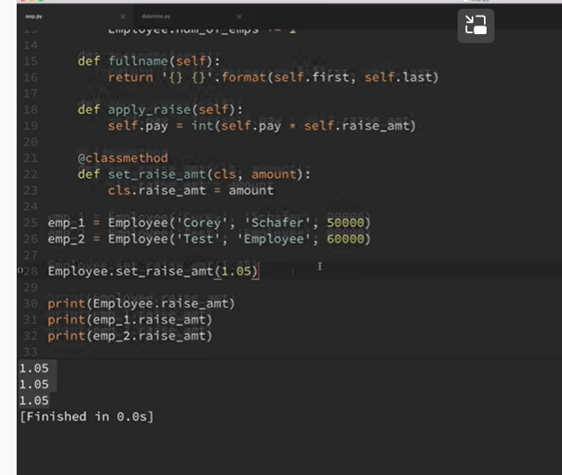

We should call that by using class name

Employee.set\_raise\_amt(1.05)

It changes raise amount to 1.05 now

